Smart Water Fountains:

Title : A Solution for Busy Pet Owners

Introduction:

As a pet owner, you want to provide the best possible care for your furry friend One important aspect of pet care is ensuring that your pet has access to clean, fresh water at all times However, with busy schedules and long hours away from home, it can be a challenge to maintain your pet's hydration needs This is where smart water fountains can be a game-changer for busy pet owners

**What is a Smart Water Fountain?**

Smart water fountains for pets are machines that give your pet clean, fresh water all the time. They come with a number of features that make them useful and easy to use for pet owners, such as:

● Automatic water flow: The water fountain ensures a consistent flow of water, which encourages pets to drink more and stay hydrated.

● Filtered water: Smart water fountains come with a filter that removes impurities and keeps the water clean and fresh.

● Real-time monitoring: Some smart water fountains come with monitoring features that let you track your pet's water intake and detect any potential issues

● Remote access: Many smart water fountains can be controlled and monitored remotely via a mobile app, making it easy to check on your pet's water intake while you're away from home

**Why Are Smart Water Fountains Ideal for Busy Pet Owners?**

Smart water fountains are ideal for busy pet owners for a number of reasons:

● Convenient: Smart water fountains are automated, meaning you don't have to manually refill your pet's water bowl every day. This is particularly helpful for pet owners with busy schedules or those who travel frequently

● Hygienic: The filtration system in smart water fountains ensures that the water is always clean and free of impurities. This helps to prevent the growth of harmful bacteria and keeps your pet healthy

● Encourages hydration: The consistent flow of water in smart water fountains encourages pets to drink more, which is essential for their overall health and wellbeing.

● Real-time monitoring: With the monitoring features in some smart water fountains, you can keep an eye on your pet's water intake and detect any potential issues, such as a decrease in water consumption or dehydration.

**Instachew PURRFLOW SMART PET FOUNTAIN**

One of the top smart pet water fountains on the market is the Instachew Purrflow Smart Pet Fountain This innovative water fountain comes with a range of features that make it ideal for busy pet owners, including:

● Real-time monitoring: The Instachew PURRFLOW SMART PET FOUNTAIN lets you monitor your pet's water intake in real-time via the mobile app This helps you to detect any changes in your pet's behavior and ensure they are staying hydrated.

● Automatic water flow: The Instachew PURRFLOW SMART PET FOUNTAIN has an automatic water flow system that ensures a consistent flow of water, encouraging your pet to drink more.

● Quadruple filtration system: The water fountain features a 4-stage filtration system that removes impurities and keeps the water fresh and clean.

● Quiet operation: The Instachew PURRFLOW SMART PET FOUNTAIN is designed to operate quietly, so it won't disturb you or your pet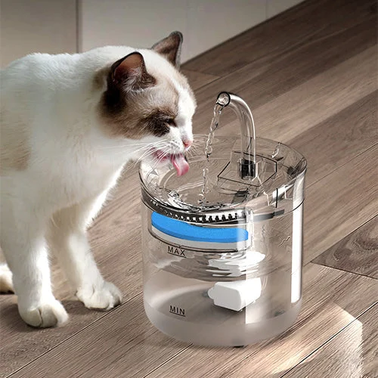

**Is a Smart Pet Water Fountain Right for Your Pet Family**

Over the past few years, pet water fountains have grown in popularity. They are practical, save time, and support optimal hydration in canines and felines Think about your pet family's needs in the long run as well as the benefits of pet water fountains before making a choice

The Instachew Purrflow Smart Pet Fountain is a great and budget-friendly choice for pet owners who are busy because it has a quadruple filtration system, runs quietly, and can be monitored in real time. By investing in a smart water fountain, you can provide your pets with the best possible care, even when you’re not home

